# [**To evolve, Law & Order had to ax one of its long-running characters**](https://www.polygon.com/23361720/law-order-svu-amanda-rollins-kelli-giddish-cast)

*Kelli Giddish’s SVU character Amanda Rollins tested the limits of the show’s ‘standing for victims’ ethos*

By [Scarlett Harris](https://www.polygon.com/users/Scarlett_Harris) Updated Sep 22, 2022, 7:47pm EDT

[80 Comments / 80 New](https://www.polygon.com/23361720/law-order-svu-amanda-rollins-kelli-giddish-cast#comments)

## **Share this story**

* [Share this on Facebook (opens in new window)](https://www.facebook.com/sharer/sharer.php?text=Law+%26+Order%3A+SVU+had+to+ax+Kelli+Giddish%E2%80%99s+Amanda+Rollins+to+evolve&u=https%3A%2F%2Fwww.polygon.com%2F23361720%2Flaw-order-svu-amanda-rollins-kelli-giddish-cast)
* [Share this on Twitter (opens in new window)](https://twitter.com/intent/tweet?counturl=https%3A%2F%2Fwww.polygon.com%2F23361720%2Flaw-order-svu-amanda-rollins-kelli-giddish-cast&text=Law+%26+Order%3A+SVU+had+to+ax+Kelli+Giddish%E2%80%99s+Amanda+Rollins+to+evolve&url=https%3A%2F%2Fwww.polygon.com%2F23361720%2Flaw-order-svu-amanda-rollins-kelli-giddish-cast&via=Polygon)
* [SHAREAll sharing options](https://www.polygon.com/23361720/law-order-svu-amanda-rollins-kelli-giddish-cast#)

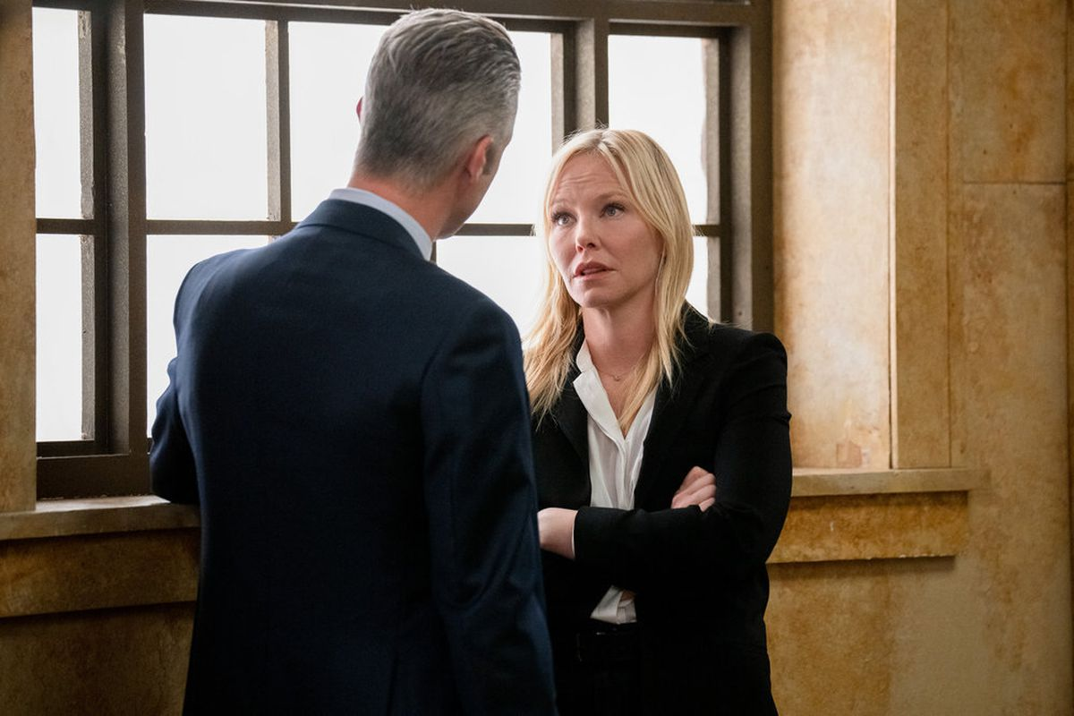*Photo: Virginia Sherwood/NBC*

Law enforcement both real and fictional has undergone a reckoning in recent years, albeit a confusing one. Many wondered, in the wake of George Floyd’s murder and the resurgence of the #BlackLivesMatter movement, [if cop shows were over](https://www.vulture.com/2020/06/tv-cops-are-always-the-main-characters.html). *Law & Order: Organized Crime* dumped its showrunner Craig Gore amidst controversial Facebook comments about the 2020 protests (the show has since had [five showrunners across its three-season tenure](https://variety.com/2022/tv/news/law-and-order-organized-crime-showrunner-sean-jablonski-replaces-bryan-goluboff-1235357166/)). And yet, last year the original *Law & Order* was resurrected, and the sister *Chicago P.D.* law enforcement franchise is going strong, so it would seem that cop shows are doubling down.

Still, cop shows no longer exist apolitically, and *Law & Order: Special Victims Unit* actress Kelli Giddish appears to have been a casualty of Law & Order’s shakeup, with her departure announced ahead of *SVU*’s 24th season premiere on Thursday. But this writer won’t miss Giddish’s Detective Amanda Rollins and her legacy of victim blaming and slut shaming, and her departure shows just how far the Law & Order universe has to go.

This is not a celebration of actress Kelli Giddish’s exit from *Law & Order: Special Victims Unit* — which [was not of her own accord](https://variety.com/2022/tv/news/why-is-kelli-giddish-leaving-law-and-order-svu-1235350955/), and was cited by the series’ new showrunner David Graziano as just part of the “complex” behind-the-scenes creative and financial decisions that steer the show — but rather of her character’s. Giddish’s Amanda Rollins entered the Dick Wolf televisual universe as a member of *SVU*’s elite squad for the show’s 13th season after the departure of Chris Meloni’s equally problematic Detective Elliot Stabler (who is now back in this role in *Organized Crime*, as well as plenty of cameos in the spinoff that made him famous). And she quickly (and often) became an example of the limits of cop shows to truly protect and serve their communities. She’s judgmental, reproachful, and probably more conservative than we know, if her defense of an Ann Coulter-like political pundit in the season 19 episode “Info Wars” is any indication.

*Photo: Virginia Sherwood/NBC*

In later seasons we find out that Rollins was raped by her former captain in Atlanta, who assaults another deputy in the season 16 episode “Forgiving Rollins.” “She’ll get over it,” Rollins says dismissively, clearly projecting her own trauma onto this survivor because it’s what Rollins herself had to do. It’s a reaction that flew in the face of how *SVU* was being received at the time, as kind of a [justice wish fulfillment](https://www.thehairpin.com/2015/01/members-of-an-elite-squad/) for survivors who hoped their assaults were treated with as much care as the dedicated detectives who investigated these vicious felonies every week on NBC, but especially Captain Olivia Benson (Mariska Hargitay), the patron saint of rape avengers.

When compared to Benson, forgiving Rollins after that was hard, even with all the baggage we come to find out about her, particularly as it relates to her sister, the infuriating Kim, played with aplomb by Lindsay Pulsipher. Having such chaotic relatives should make Rollins relatable and sympathetic. And yet, her story is always poorly written and allows for the least charitable read on her as a character that prevents her from growing, with her twin superiority complex at seemingly having risen above her toxic family yet always regressing.

Though we have empathy for Rollins and understand why she sometimes responds questionably to survivors whom she doesn’t deem to behave the right way, she doesn’t perform her job with that same empathy. A halfhearted plot line of her going to therapy to work through her toxic upbringing ended in her being held hostage (and that’s it). The episode that completely soured me to the character was season 19’s “Service,” when Rollins questions why SVU “give[s] a damn” about sex workers who have been assaulted. For a detective tasked with bringing rapists to justice to have such derision toward a group of people who have between [45% to 75% likelihood of experiencing sexual violence on the job](https://swp.urbanjustice.org/wp-content/uploads/sites/14/2020/08/Fact-Sheet-Sexual-Violence-Against-Sex-Workers-1-1-1.pdf), according to the Urban Justice Center, is sickening.

And it’s there that Rollins represents the uphill battle *SVU* and its brethren are still badly waging. The show’s “ripped from the headlines” schema doesn’t always allow enough distance from these newsworthy crimes for *SVU* to handle them with the sensitivity they warrant (which is [a problem with the true-crime genre in general](https://www.refinery29.com/en-au/2022/08/11083289/true-crime-tv-survivors)). *SVU* had the opportunity to change how it represented policing in late 2020’s season 22 return; however, many will argue that the damage the franchise has done to the perception of policing over the course of two decades cannot be undone in a few months. As it was, season 22’s premiere episode took on white woman Amy Cooper calling the cops on Black birdwatcher Christian Cooper (no relation) in Central Park’s the Ramble that occurred the same day as George Floyd’s murder, making no effort to unpack the racial reckoning of that summer with any of the care that made survivors fall in love with the show. With *SVU* tackling the Amber Heard/Johnny Depp case in the upcoming 24th season, and with the overturning of *Roe v. Wade* earlier this year, the show will likely be factoring more ripped-from-the-headlines plot lines into its schema.

Detective Rollins isn’t *SVU*’s only problem; she’s just one part of a wider issue with cop shows and law enforcement more broadly. She was protected from ever having to grow up and learn from her mistakes. Getting rid of her isn’t going to solve every *Law & Order* problem, but it’s at least a step in the right direction.